Identifying the main message - topic sentences
Students are often required to do a large amount of reading. To save time and to select the best text(s) for your needs. It is important to identify the main message as quickly as possible.
To do this:
- Look at the title
- Quickly skim the text to find the topic sentences. They are usually the first sentence in each paragraph. They summarize what the paragraph is about.
Task 1 Scan the text The Silent Plane. Pay attention to topic sentences only. Are the statements true (T) or false (F)?
- Maybe one day planes won’t make a noise.
- Noise is being reduced in two ways.
- The project to build the plane hasn’t begun yet.
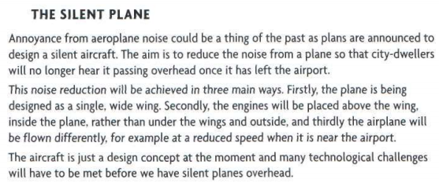
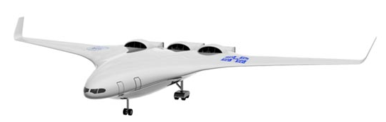
Task 2 Read the summaries a-d of the paragraphs in the article The Car that Drives Itself. Match them with the topic sentences 1-4. Do not read the article.

Summaries | Topic sentences
a describing how the car works | 1 A car manufacturer has designed and built a car that drives itself.
b predicting future developments | 2 Despite these disadvantages, car manufacturers see driverless cars as the future.
c outlining some problems | 3 However, there are still two main drawbacks.
d introducing the subject | 4 the car works using two main devices.

Task 3 Skim the article to match the topic sentences from Task 2 to paragraphs A-D. Use the summaries to help.



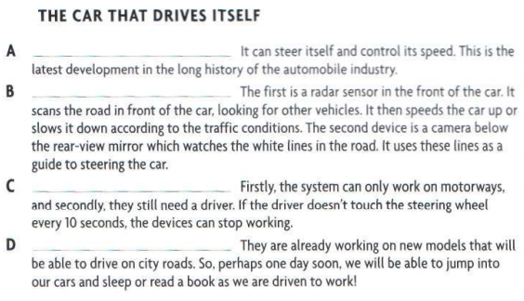

Task 4 Make an outline of a talk about an innovation in your professional sphere.

